**Bugs-cinema city**

**I checked in the browser -ios on the iphone 13 pro max + iphon xs+ iphon xs max**

**Title**-credit card payment screen cut off

**Description-**

**1.** Opens the app

**2**. Book tickets-

הזמן כרטיסים

**3.** choosing-

סינמה סיטי ראשל"צ

סרט גן הקופים, יום שלישי 28/11/2023 בשעה 19:00

**4.** Click on the button-

הזמן עכשיו

**5**.a page opens- seat selection- Chooses 2 seats row 9 chairs 3,4

**6**.click on the button-

הבא

**7**.select a card type-regular

**8**.a page for entering details will open -entering details

**9**. Marks v in the field

מאשר/ת שקראתי והבנתי את התקנון

**10**. Click on the button-

לתשלום בכרטיס אשראי

**Expected result-**

That the page in not cut and you can see all the details that are entered

**Actual result-**

The page that opens is cut off and it is difficult to enter credit information

**Severity**

High

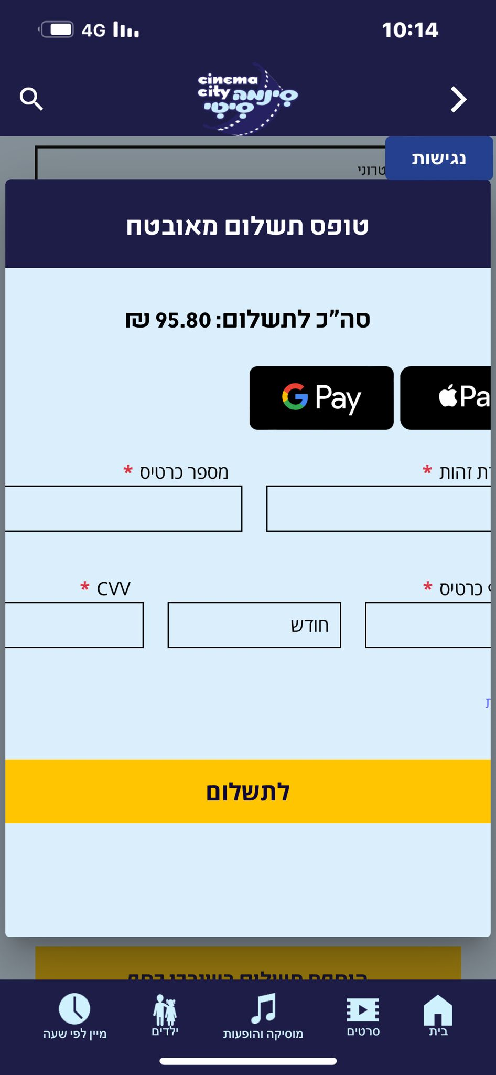

**Bug**

**Title-** in the search bar typing in a value that doesn’t exist gets logs

**Description-**

**1.**the home page has a search bar

**2**.you can search for a movie

**3**.i did a negative test in several ways and each time I get the same results:

I typed a movie that is no longer in cinema--

שר הטבעות.

* I typed over 100 letters.-
* Typing in numbers-
* - Type symbols !..,*****
* Typing in Hebrew a word that does not exist
* עכייחחעעע

**4**.with clicking on the search box where I typed

**Expected result**- no logs should appear ,just an error message

**Actual result**-you get a page with logs

**Severity-** low

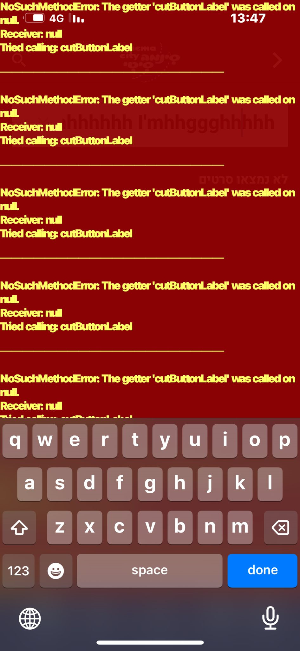

**Bug**

**Titel-**

a search bar that records an existing movie receives no movies found

**Description-**

**1.** the home page has a search bar

**2.** The keyboard has the option to record

**3**. Record button

**4.**recording a movie that exists now-

רומן צרפתי

**Expected result-**

Looking forward to finding the movie

**Actual result-**receiving

לא נמצאו סרטים

**Severity-**medium

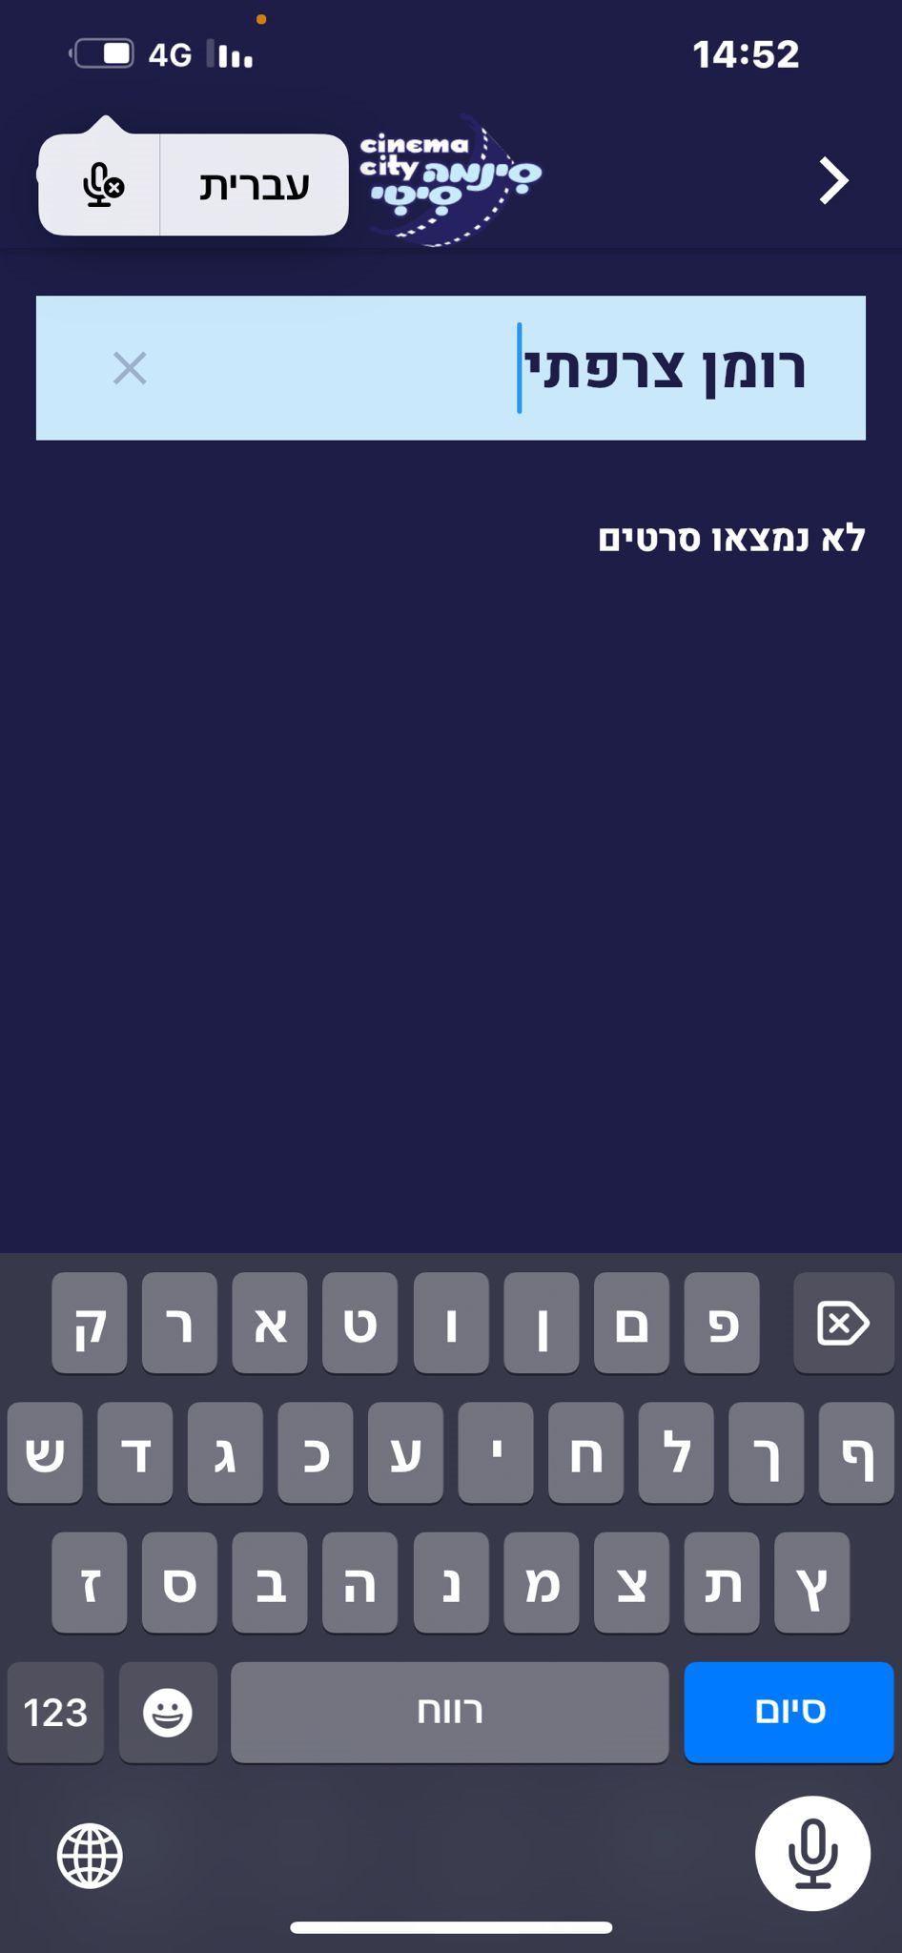

**Bug**

**Titel-**bug Gui- the boxes are not straight.

**Description-**

**1.** On the home page

**2.** Image with a direct link to order tickets

הכפתור הלבן-להזמנת כרטיסים

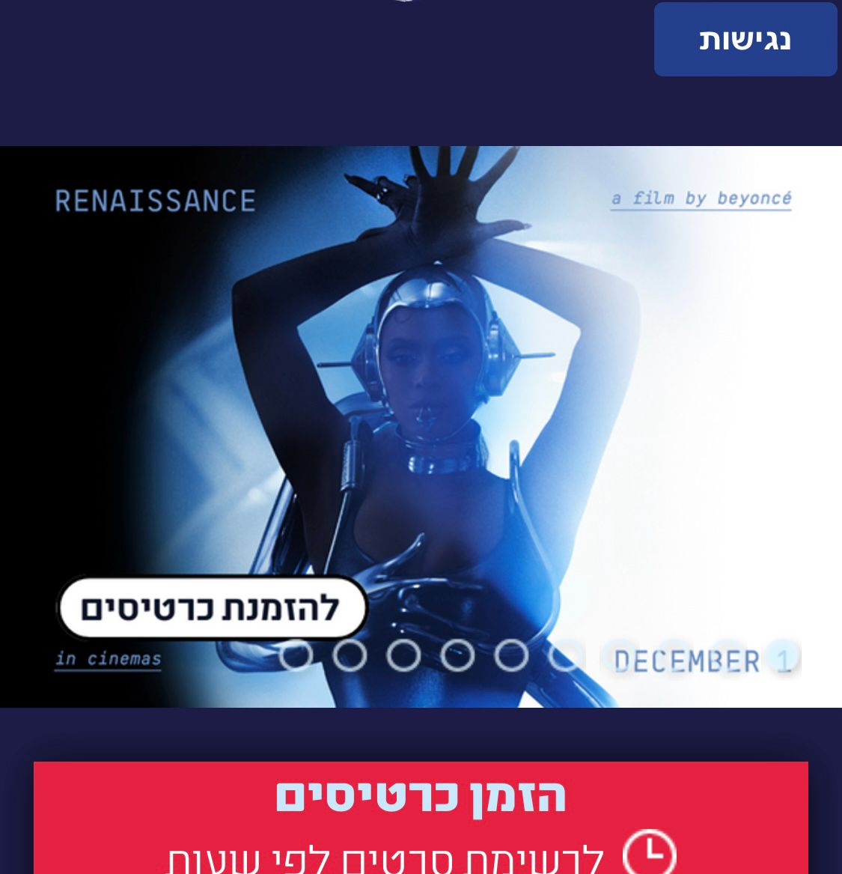

**3.** Click on the button-

להזמנת כרטיסים

**4**. Scrolling down –

הזמן כרטיסים לסרט זה

**Expected result-**that the boxes were one below the other straight.

**actual result-**the boxes are not straight.

**severity-**low

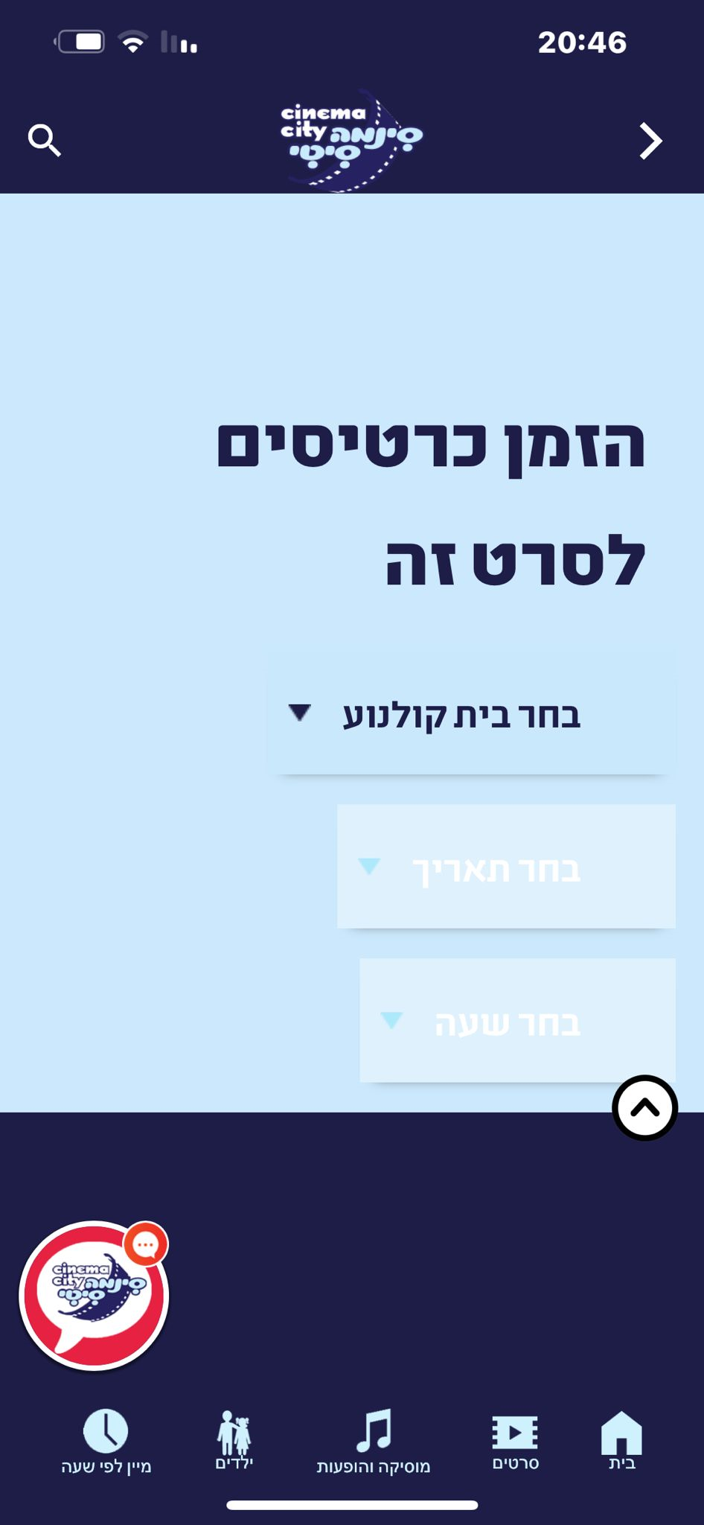

**Bug**

**Title-** movie premiere date does not match ticket booking

**Description-**

**1.** On the home page

**2.**entered a list of movies

**3**.in the movie**-**

טרולים מופיע באדום 7/12

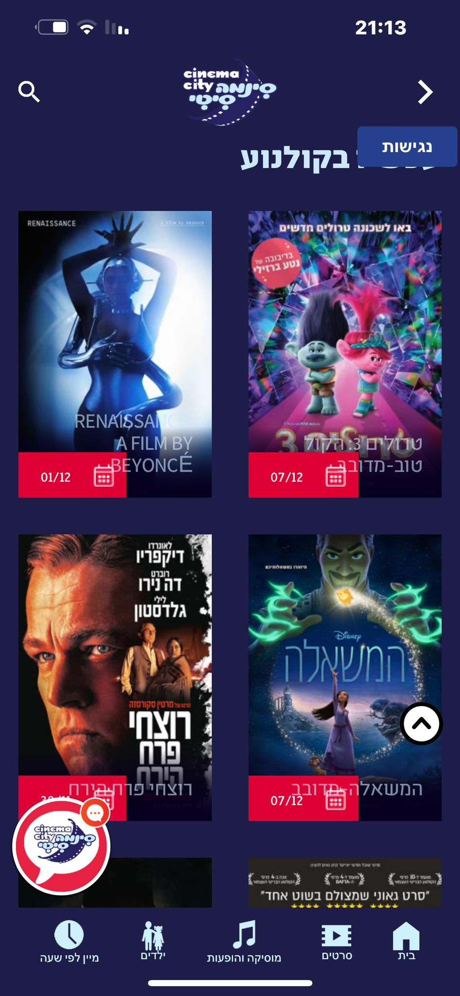

**4.**go into details about the movie

**5.**premiere date 07/12/2023

**Expected result-**you can see the movie starting 07/12/2023

**actual result**-tickets can be purchased before the date 02/12/2023

**severity**-medium

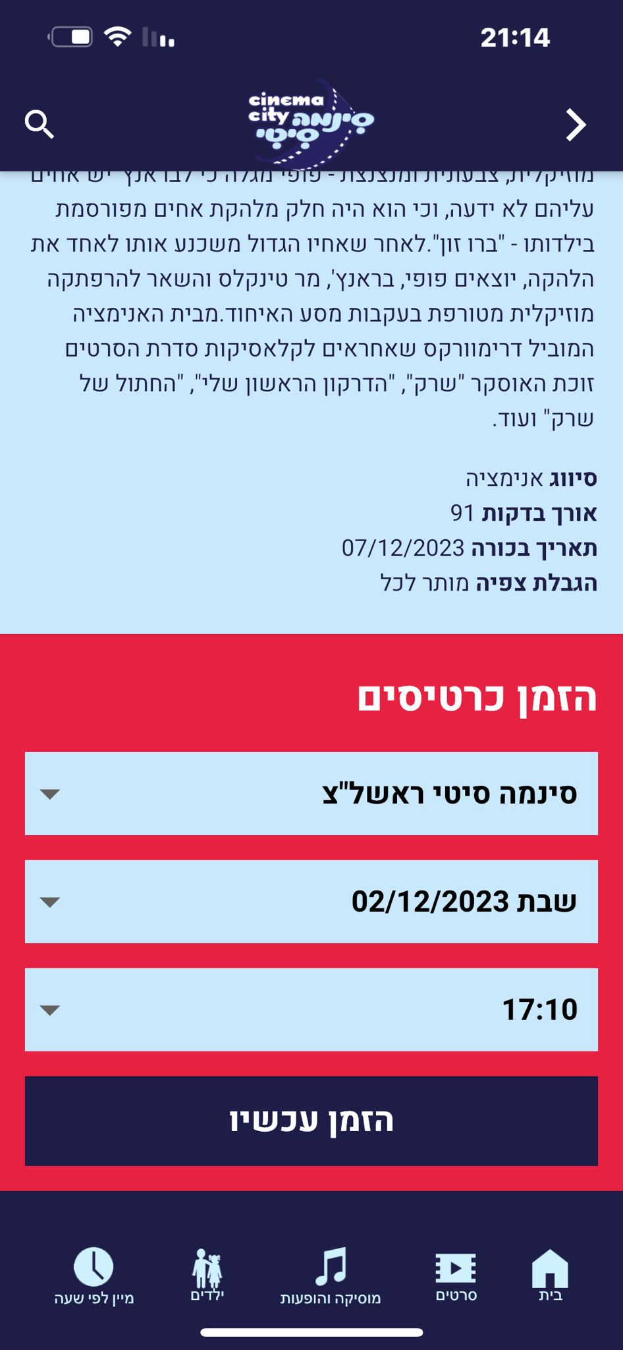

**Bug**

**Title**-apple pay payment button not responding.

**Description-**

**1.** You press the button-

לתשלום בכרטיס אשראי

**2**. On the top right there is an icon- apple pay

**3**. Click on-apple pay

**4**. A page opens-

מזינה תעודת זהות

**5**.Typing- 22560718

**6**. Press down on a button- PAY

**Expected result-**

Looking forward to the next page

**actual result-**

The button does not respond

**severity**-high

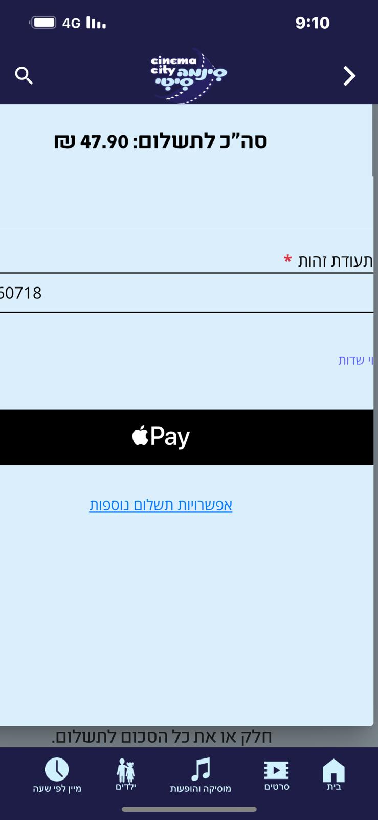

**Bug**

**Title**-who click on PayPal payment you get a blank white page

**Description-**

**1.** Choosing-

סינמה סיטי נתניה

יום ראשון 03/12/2023

חג ההודיה

21:40

**2**. selects seats

**3**.entering details

**4**. Approval of regulations

**5**. You press the button-

PayPal

**Expected result-** Will take me to the page of PayPal

**actual result-** A white page opens and the application crashes

**severity**-high

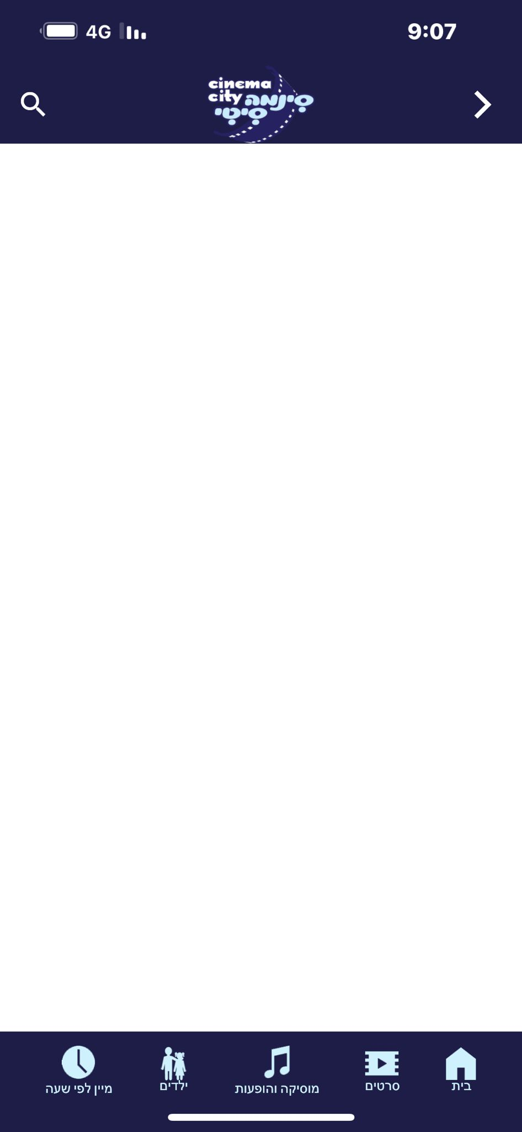

**Bug- gui**

**Title**-the verification code screen is cut off at the end

**Description-**

1.On the right click on the menu and choose-

בדיקה/ביטול הזמנה

**2.** A personal area page will open

3. A mobile phone must be tapped.

4. After you enter the phone

5. A verification code to has been sent to a mobile phone

6. Sent message to the phone

7.a box will open to type a verification code

**Expected result**-the lest word will not be cut

**actual result**--the verification code screen is cut off at the lest word

**severity**-low

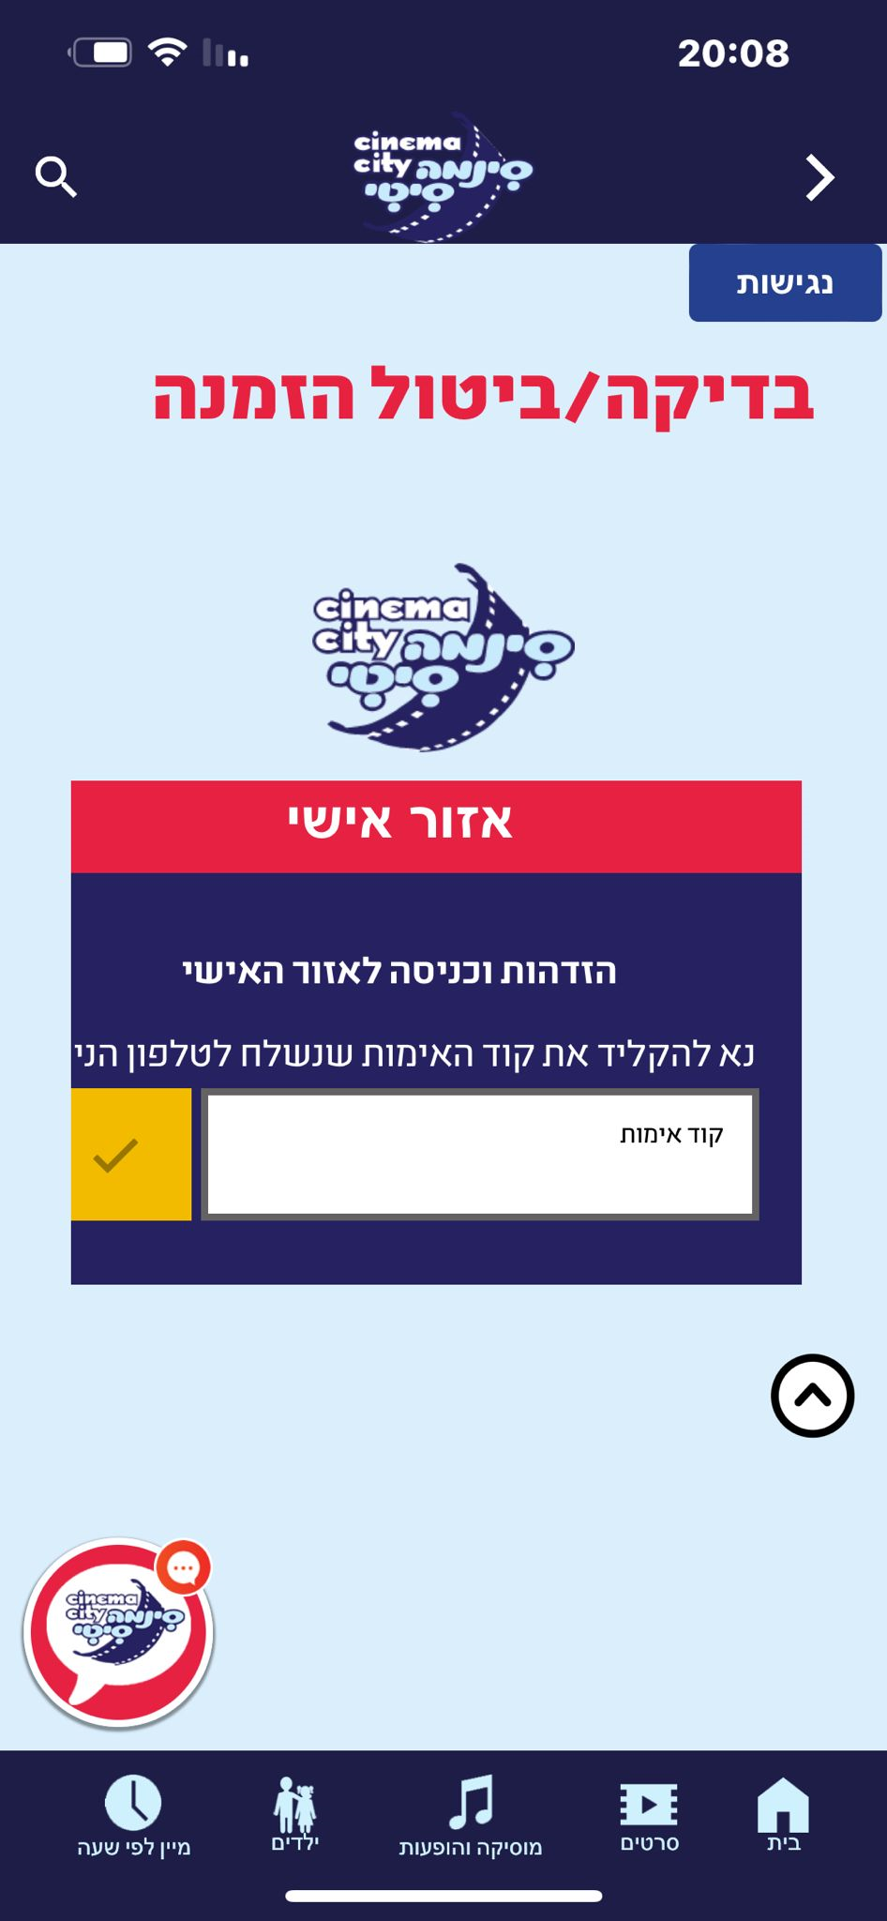

**Bug- gui**

**Title**-the x of the exit appears on the personal area

**Description-**

**1.** .On the right click on the menu and choose-

בדיקה/ביטול הזמנה

**2**. A personal area page will open

**3.** A mobile phone must be tapped.

**4.** After you enter the phone

**5**. A verification code to has been sent to a mobile phone

**6**. Sent message to the phone

**7**. a box will open to type a verification code

**8**.type the verification code and a personal area will open

**Expected result-**that the exit button will appear above the box of the personal area

**actual result**-the exit button appears on the personal area box

**severity**-low

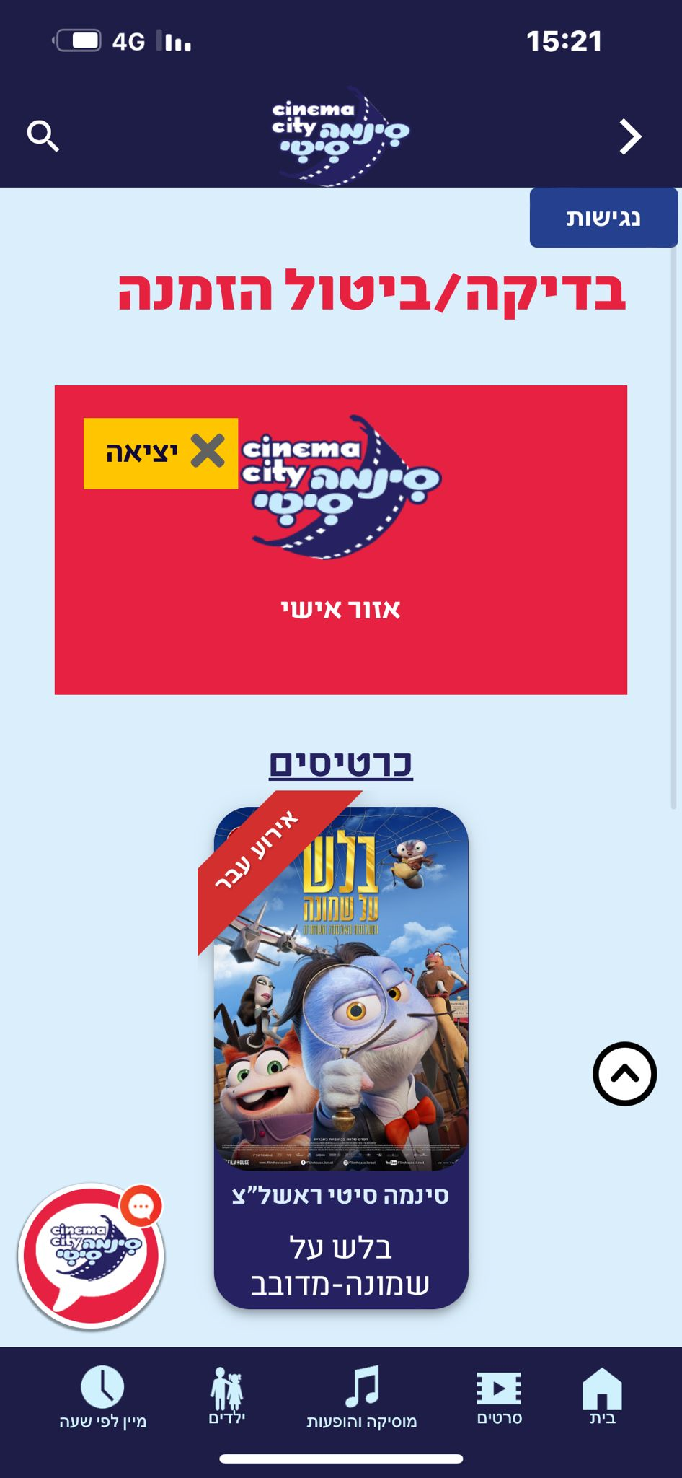

**Bug**

**Title**-bug coming soon in the cinema the ticket booking button is not responding.

**Description-**

**1.**on the home page on the right you enter the menu

**2.**entered the-

בקרוב בקולנוע

**3.**entered a list of movies

**4.**you entered one of the movies

**5.**you press the button-

להזמנת כרטיסים

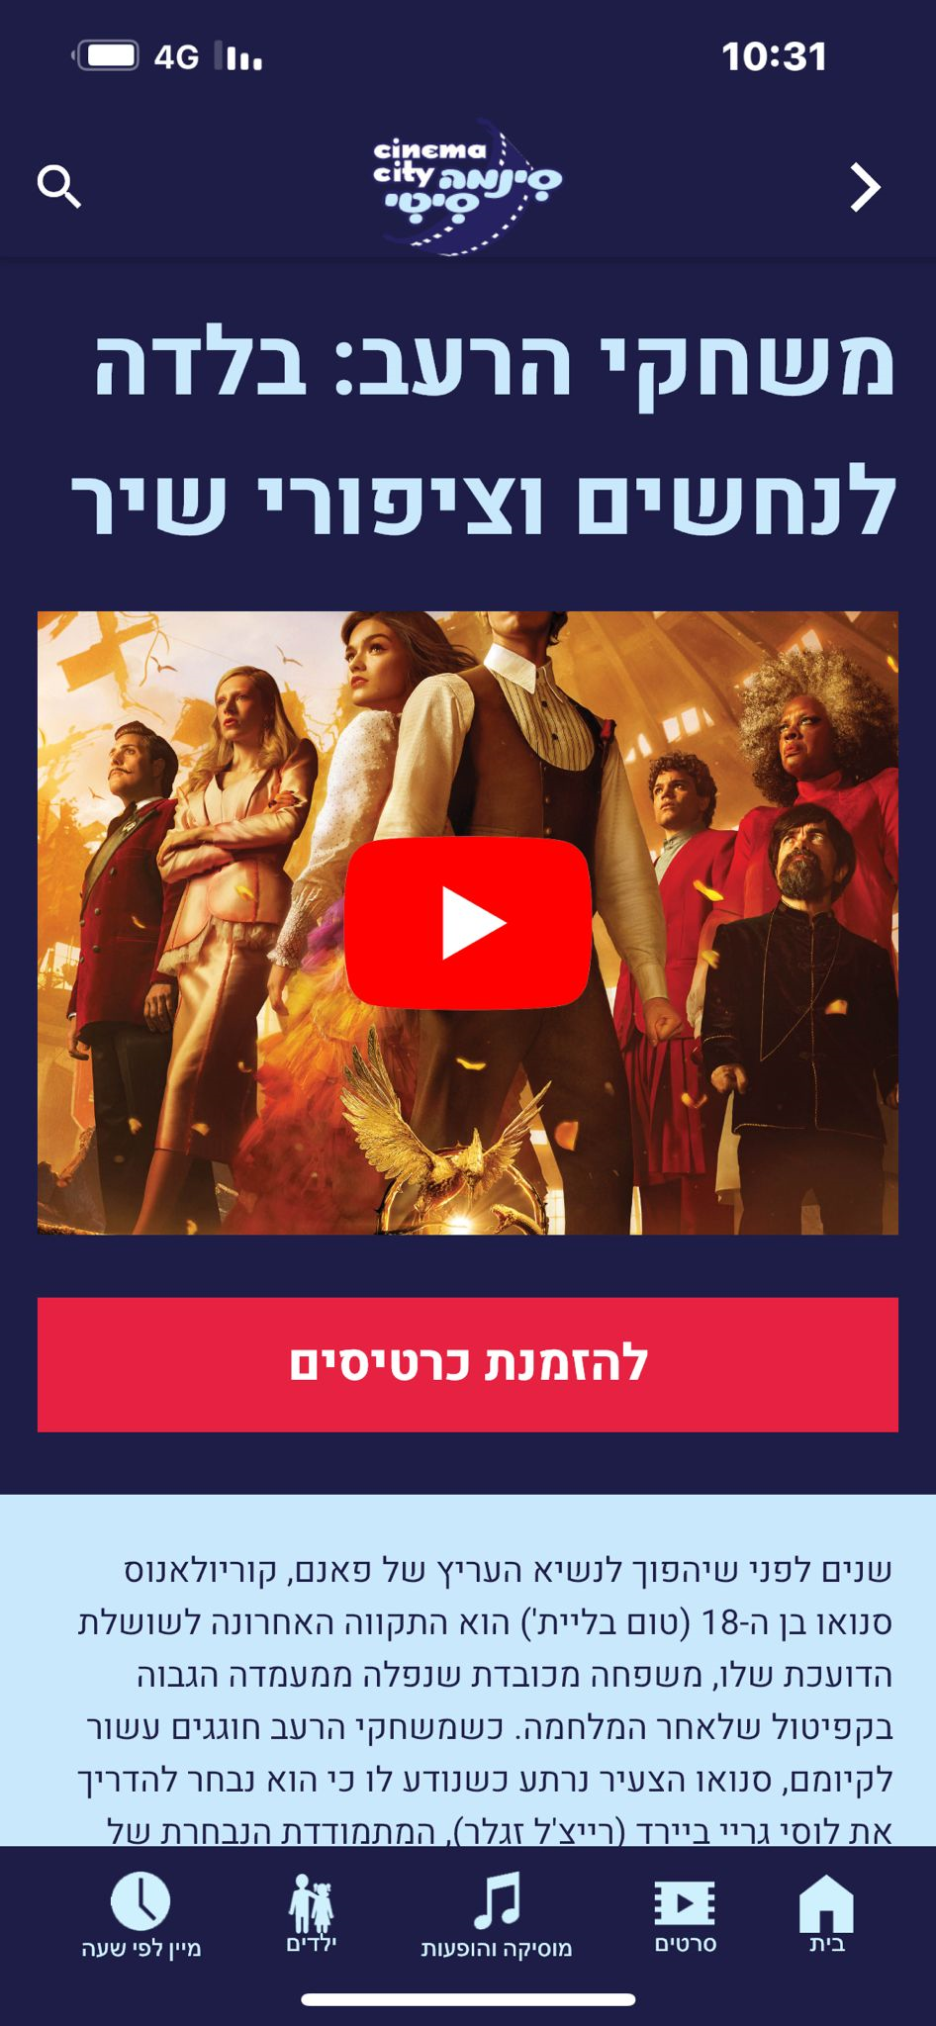

**Expected result-**a page will open to order tickets

**actual result-gets** a blue screen and returns to the same screen (the screen in the picture above)

**severity**-medium

